Single Adjust Side Release Buckle
Buckle used as our belt clasp. This is used to attach both sides of the belt to one another, as well as to tighten/loosen the belt as desired.
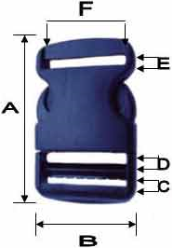
Size | A | B | C | D | E | F
1 ½ inch | 2.74 inch | 1.84 inch | 0.17 inch | 0.19 inch | 0.20 inch | 1.50 inch

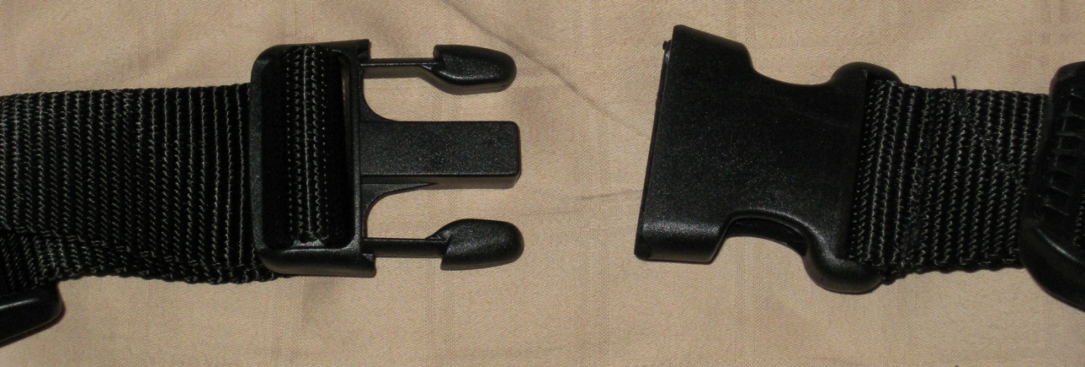
Figure 1.1: 1½ inch single adjust side release buckle

